MACHINE LEARNIING

LAB MANUAL

B.TECH VI SEMESTER

(R22 REGULATION)

COMPUTER SCIENCE AND ENGINEERING

DEPARTMENT OF COMPUTER SCIENCE AND ENGINEERING

VAAGDEVI COLLEGE OF ENGINEERING
BOLLIKUNTA, WARANGAL

SYLLABUS FOR MACHINE LEARNING LAB

List of Experiments
1. Write a python program to compute Central Tendency Measures: Mean, Median, Mode Measure of Dispersion: Variance, Standard Deviation?
2. Study of Python Basic Libraries such as Statistics, Math, Numpy and Scipy.
3. Study of Python Libraries for ML application such as Pandas and Matplotlib.
4. Write a Python program to implement Simple Linear Regression.
5. Implementation of Multiple Linear Regression for House Price Prediction using sklearn.
6. Implementation of Decision tree using sklearn and its parameter tuning.
7. Implementation of KNN using sklearn.
8. Implementation of Logistic Regression using sklearn.
9. Implementation of K-Means Clustering.
10. Performance analysis of Classification Algorithms on a specific dataset (Mini Project)
Course Objective:
- The objective of this lab is to get an overview of the various machine learning
techniques andcan demonstrate them using python.
Course Outcomes:
1. Understand modern notions in predictive data analysis.
2. Select data, model selection, model complexity and identify the trends.
3. Understand a range of machine learning algorithms along with their strengths andweaknesses
4. Build predictive models from data and analyze their performance.

TEXT BOOK:
1. Machine Learning – Tom M. Mitchell, - MGH.
REFERENCE BOOK:
1. Machine Learning: An Algorithmic Perspective, Stephen Marshland, Taylor & Francis.
List of Experiments
1. Write a python program to compute Central Tendency Measures:

WEEK-1:

- write a python program to compute central tendency measures mean median mode measure of dispersion variance standard deviation

import statistics

def calculate_mean(data):
return sum(data) / len(data)

def calculate_median(data):
sorted_data = sorted(data)
n = len(sorted_data)
if n % 2 == 0:
middle1 = sorted_data[n // 2 - 1]
middle2 = sorted_data[n // 2]
return (middle1 + middle2) / 2

else:
return sorted_data[n // 2]

def calculate_mode(data):
returnstatistics.mode(data)

def calculate_variance(data):
mean_value = calculate_mean(data)
squared_diff_sum = sum((x - mean_value) ** 2 for x in data)
return squared_diff_sum / (len(data) - 1)

def calculate_standard_deviation(data):
variance_value = calculate_variance(data)
return variance_value ** 0.5

# Example dataset
dataset = [10, 20, 30, 40, 50]
mean_value = calculate_mean(dataset)
median_value = calculate_median(dataset)
mode_value = calculate_mode(dataset)
variance_value = calculate_variance(dataset)
std_deviation_value = calculate_standard_deviation(dataset)
print(f"Dataset: {dataset}")
print(f"Mean: {mean_value:.2f}")
print(f"Median: {median_value:.2f}")
print(f"Mode: {mode_value}")
print(f"Variance: {variance_value:.2f}")
print(f"Standard Deviation: {std_deviation_value:.2f}")

output : Dataset: [10, 20, 30, 40, 50]
Mean: 30.00
Median: 30.00
Mode: 10
Variance: 250.00
Standard Deviation: 15.
OUTPUT : Dataset: [10, 20, 30, 40, 50]
Mean: 30.00
Median: 30.00
Mode: 10
Variance: 250.00
Standard Deviation: 15.81
WEEK-2:
2) Study of Python Basic Libraries such as Statistics, Math, Numpy and Scipy
Import numpy as np
# Create a 1D array
arr1d = np.array([1, 2, 3])
print(f"1D Array: {arr1d}")
# Create a 2D
arrayarr2d = np.array([[1, 2, 3], [4, 5, 6]])
print(f"2D Array: {arr2d}").
=> SciPy(Scientific Python):SciPy builds upon NumPy and provides additional functionality for scientific and engineering purposes.
It includes modules for optimization, integration, linear algebra, signal processing, and more.
Example usage:Pythonimportscipy.optimize as opt
# Solve an optimization problem
def objective(x):
return x[0]**2 + x[1]**2
result = opt.minimize(objective, [1, 1])
print(f"Optimal solution: {result.x}")
# Perform numerical integration
fromscipy.integrate import quad
def integrand(x):
return x**2
area, error = quad(integrand, 0, 2)
print(f"Integral result: {area:.2f}")
- Python’s Built-instatisticsModule: Thestatisticsmodule,
- introduced in Python 3.4, provides functions for calculating mathematical statistics of numeric data. It includes measures of central location (such as mean, median, and mode) and measures of spread (such as standard deviation and variance).
- Note that this module is not intended to compete with third-party libraries like NumPy or SciPy, which offer more extensive statistical capabilities.
- Instead, it’s suitable for basic statistical calculations and graphing Customization: You can control colors, labels, and other plot properties.

WEEK-3:
3) Study of Python Libraries for ML application such as Pandas and Matplotlib.
Integration with Pandas: Matplotlib works seamlessly with Pandas
import numpy as np
import pandas as pd
import matplotlib.pyplot as plt
df=pd.read_csv('CAR DETAILS FROM CAR DEKHO.csv')
df
df['fuel'].value_counts()
df['owner'].value_counts()
df['seller_type'].value_counts()
df['transmission'].value_counts()

le=LabelEncoder()
df['fuel']=le.fit_transform(df['fuel'])
df['seller_type']=le.fit_transform(df['seller_type'])
df['transmission']=le.fit_transform(df['transmission'])
df['owner']=le.fit_transform(df['owner'])
df
plt.figure(figsize=(12,6))
plt.scatter(x=df['km_driven'],y=df['selling_price'])
plt.xlabel('Kms_driven')
plt.ylabel('selling price in lakhs')
plt.title('Kilo_meters vs Selling_price')
plt.show()
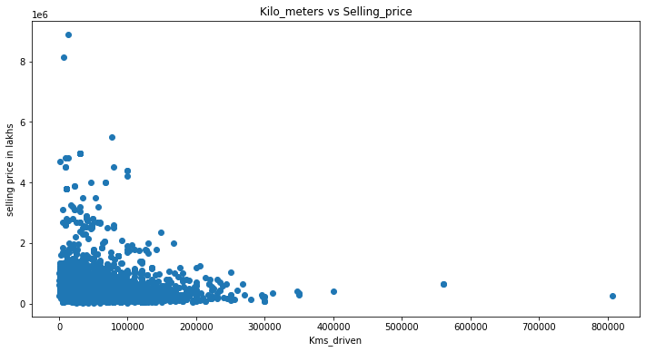
plt.figure(figsize=(12,6))
plt.scatter(x=df['fuel'],y=df['selling_price'])
plt.xlabel('fuel')
plt.ylabel('Selling_price in lakhs')
plt.title('fuel vs selling_price')
plt.show()
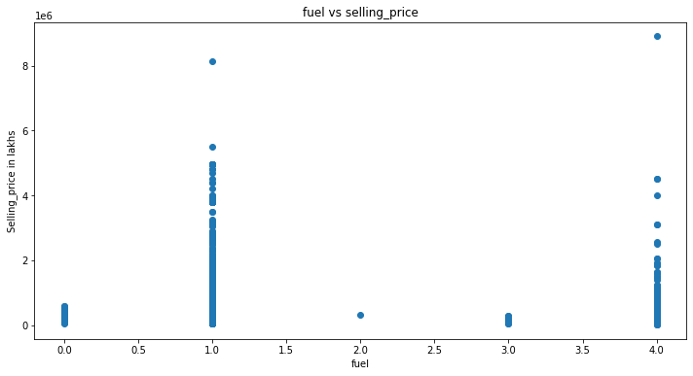
plt.figure(figsize=(12,6))
plt.scatter(x=df['seller_type'],y=df['selling_price'])
plt.xlabel('seller_type')
plt.ylabel('selling_price in lakhs')
plt.title('seller_type vs selling_price')
plt.show()
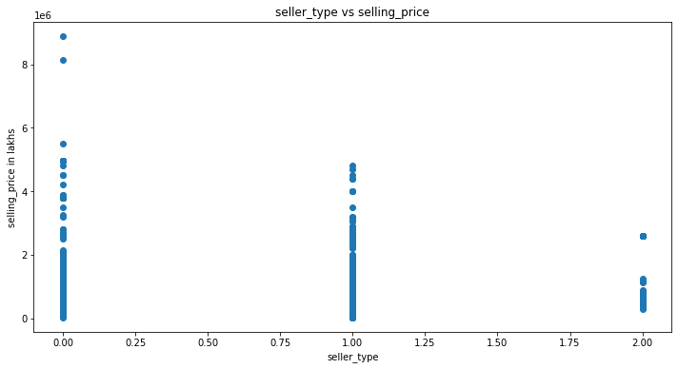
plt.scatter(x=df['transmission'],y=df['selling_price'])
plt.xlabel('transmission')
plt.ylabel('selling_price in lakhs')
plt.title('Transmission vs Selling_price')
plt.show()
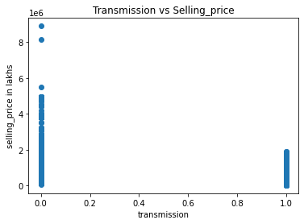

plt.figure(figsize=(15,9))
plt.pie(x=df['fuel'].value_counts(),autopct='%1.0f%%', pctdistance=0.5,explode=[0.1,0.1,0.1,0.1,0.1],labels=['Diesel','Petrol','CNG','LPG','Electric'])
plt.title('Proportion of fuels')
plt.legend()
plt.tight_layout()
plt.show()

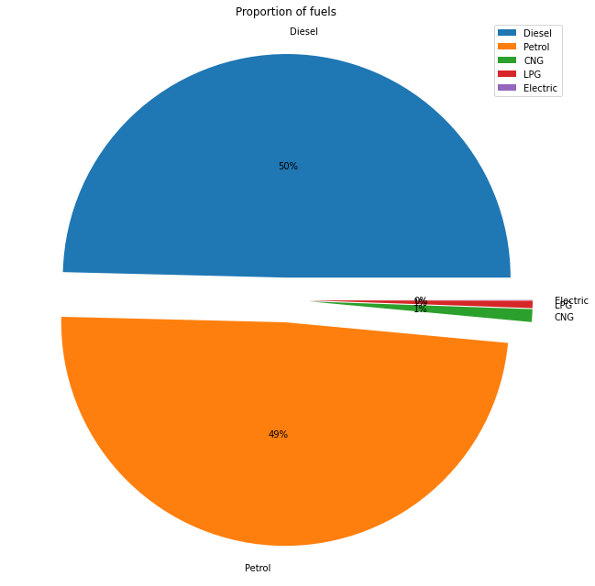
plt.figure(figsize=(15,9))
plt.pie(x=df['seller_type'].value_counts(),autopct='%1.0f%%', pctdistance=1.1, labeldistance=0.7,labels=['Individual','Dealer','Trustmark Dealer'])
plt.title('Proportion of sellers')
plt.legend()
plt.tight_layout()
plt.show()

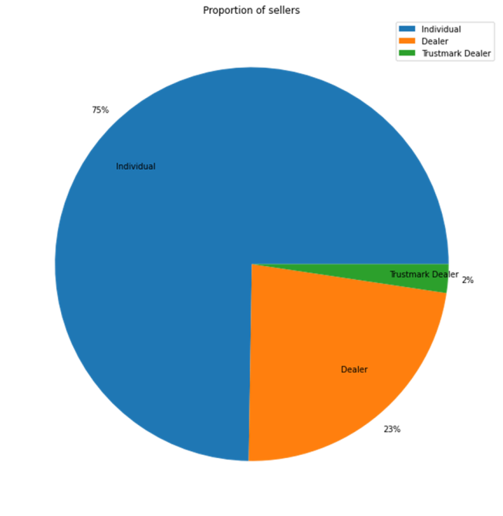

WEEK-4:
4) Write a python program to implement simple linear regression
# Import necessary libraries
Importnumpy as np
fromsklearn.linear_model import LinearRegression
importmatplotlib.pyplot as plt
# Generate some sample data
X = np.array([[1], [2], [3], [4], [5]]) # Independent variable (feature)
y = np.array([2, 4, 5, 4, 6]) # Dependent variable (response)
# Create a linear regression model
reg = LinearRegression().fit(X, y)
# Get the coefficients and intercept
slope = reg.coef_[0]
intercept = reg.intercept_
print(f"Slope (Coefficient): {slope:.2f}")
print(f"Intercept: {intercept:.2f}")
# Predict a new value
new_X = np.array([[6]])
predicted_y = reg.predict(new_X)
print(f"Predicted value for X = 6: {predicted_y[0]:.2f}")
# Plot the data and regression line
plt.scatter(X, y, color='blue', label='Data points')
plt.plot(X, reg.predict(X), color='red', label='Regression line')
plt.xlabel('X')
plt.ylabel('y')
plt.title('Simple Linear Regression')
plt.legend()
plt.show()

OUTPUT:

Slope (Coefficient): 0.80
Intercept: 1.60
Predicted value for X = 6: 6.40

WEEK-5:
5) Implementation of multiple linear regression for house price prediction using sklearn.
# importing modules and packages
import pandas as pd
import numpy as np
import matplotlib.pyplot as plt
import seaborn as sns
from sklearn.model_selection import train_test_split
from sklearn.linear_model import LinearRegression
from sklearn.metrics import mean_squared_error, mean_absolute_error
from sklearn import preprocessing

# importing data
df = pd.read_csv('Real estate.csv')
df.drop('No', inplace=True, axis=1)

print(df.head())

print(df.columns)

# plotting a scatterplot
sns.scatterplot(x='X4 number of convenience stores',
y='Y house price of unit area', data=df)

# creating feature variables
X = df.drop('Y house price of unit area', axis=1)
y = df['Y house price of unit area']

print(X)
print(y)

# creating train and test sets
X_train, X_test, y_train, y_test = train_test_split(
X, y, test_size=0.3, random_state=101)

# creating a regression model
model = LinearRegression()

# fitting the model
model.fit(X_train, y_train)

# making predictions
predictions = model.predict(X_test)

# model evaluation
print('mean_squared_error : ', mean_squared_error(y_test, predictions))
print('mean_absolute_error : ', mean_absolute_error(y_test, predictions))

OUTPUT:
X1 transaction date X2 house age … X6 longitude Y house price of unit area
0 2012.917 32.0 … 121.54024 37.9
1 2012.917 19.5 … 121.53951 42.2
2 2013.583 13.3 … 121.54391 47.3
3 2013.500 13.3 … 121.54391 54.8
4 2012.833 5.0 … 121.54245 43.1
[5 rows x 7 columns]
Index([‘X1 transaction date’, ‘X2 house age’,
‘X3 distance to the nearest MRT station’,
‘X4 number of convenience stores’, ‘X5 latitude’, ‘X6 longitude’,
‘Y house price of unit area’],
dtype=’object’)
X1 transaction date X2 house age … X5 latitude X6 longitude
0 2012.917 32.0 … 24.98298 121.54024
1 2012.917 19.5 … 24.98034 121.53951
2 2013.583 13.3 … 24.98746 121.54391
3 2013.500 13.3 … 24.98746 121.54391
4 2012.833 5.0 … 24.97937 121.54245
.. … … … … …
409 2013.000 13.7 … 24.94155 121.50381
410 2012.667 5.6 … 24.97433 121.54310
411 2013.250 18.8 … 24.97923 121.53986
412 2013.000 8.1 … 24.96674 121.54067
413 2013.500 6.5 … 24.97433 121.54310
[414 rows x 6 columns]
0 37.9
1 42.2
2 47.3
3 54.8
4 43.1
…
409 15.4
410 50.0
411 40.6
412 52.5
413 63.9
Name: Y house price of unit area, Length: 414, dtype: float64
mean_squared_error : 46.21179783493418
mean_absolute_error : 5.392293684756571

WEEK-6:
6) Implementation of Decision tree using sklearn and its parameter tuning.

# Importing the required packages
import numpy as np
import pandas as pd
from sklearn.metrics import confusion_matrix, accuracy_score, classification_report
from sklearn.model_selection import train_test_split
from sklearn.tree import DecisionTreeClassifier
import matplotlib.pyplot as plt
# Function to import the dataset
def importdata():
balance_data = pd.read_csv(
‘/ml/machine-learning-' +
'databases/balance-scale/balance-scale.data',
sep=',', header=None)
# Displaying dataset information
print("Dataset Length: ", len(balance_data))
print("Dataset Shape: ", balance_data.shape)
print("Dataset: ", balance_data.head())
return balance_data
# Function to split the dataset into features and target variables
def splitdataset(balance_data):
# Separating the target variable
X = balance_data.values[:, 1:5]
Y = balance_data.values[:, 0]

# Splitting the dataset into train and test
X_train, X_test, y_train, y_test = train_test_split(
X, Y, test_size=0.3, random_state=100)

return X, Y, X_train, X_test, y_train, y_test
def train_using_gini(X_train, X_test, y_train):
# Creating the classifier object
clf_gini = DecisionTreeClassifier(criterion="gini",
random_state=100, max_depth=3, min_samples_leaf=5)

# Performing training
clf_gini.fit(X_train, y_train)
return clf_gini
def train_using_entropy(X_train, X_test, y_train):
# Decision tree with entropy
clf_entropy = DecisionTreeClassifier(
criterion="entropy", random_state=100,
max_depth=3, min_samples_leaf=5)

# Performing training
clf_entropy.fit(X_train, y_train)
return clf_entropy
# Function to make predictions
def prediction(X_test, clf_object):
y_pred = clf_object.predict(X_test)
print("Predicted values:")
print(y_pred)
return y_pred

# Placeholder function for cal_accuracy
def cal_accuracy(y_test, y_pred):
print("Confusion Matrix: ",
confusion_matrix(y_test, y_pred))
print("Accuracy : ",
accuracy_score(y_test, y_pred)*100)
print("Report : ",
classification_report(y_test, y_pred))
# Function to plot the decision tree
def plot_decision_tree(clf_object, feature_names, class_names):
plt.figure(figsize=(15, 10))
plot_tree(clf_object, filled=True, feature_names=feature_names, class_names=class_names, rounded=True)
plt.show()
if __name__ == "__main__":
data = importdata()
X, Y, X_train, X_test, y_train, y_test = splitdataset(data)

clf_gini = train_using_gini(X_train, X_test, y_train)
clf_entropy = train_using_entropy(X_train, X_test, y_train)

# Visualizing the Decision Trees
plot_decision_tree(clf_gini, ['X1', 'X2', 'X3', 'X4'], ['L', 'B', 'R'])
plot_decision_tree(clf_entropy, ['X1', 'X2', 'X3', 'X4'], ['L', 'B', 'R'])
OUTPUT:

DATA INFO
Dataset Length: 625
Dataset Shape: (625, 5)
Dataset: 0 1 2 3 4
0 B 1 1 1 1
1 R 1 1 1 2
2 R 1 1 1 3
3 R 1 1 1 4
4 R 1 1 1 5

WEEK-7:
7) Implementation of KNN using sklearn.
#Load the necessary python libraries
importnumpyasnp
importpandasaspd
importmatplotlib.pyplotasplt
plt.style.use('ggplot')
#Load the dataset
df=pd.read_csv('../input/diabetes.csv')

#Print the first 5 rows of the dataframe.
df.head()

Pregnancies Glucose BloodPressure SkinThickness Insulin BMI DiabetesPedigreeFunction Age Outcome
0 6 148 72 35 0 33.6 0.627 50 1
1 1 85 66 29 0 26.6 0.351 31 0
2 8 183 64 0 0 23.3 0.672 32 1
3 1 89 66 23 94 28.1 0.167 21 0
4 0 137 40 35 168 43.1 2.288 33 1
#Let's observe the shape of the dataframe.
df.shape
Out[3]:
(768, 9)
#Let's create numpy arrays for features and target
X=df.drop('Outcome',axis=1).values
y=df['Outcome'].values
X_train,X_test,y_train,y_test=train_test_split(X,y,test_size=0.4,random_state=42,stratify=y)
#import KNeighborsClassifier
from sklearn.neighbors import KNeighborsClassifier

#Setup arrays to store training and test accuracies
neighbors= np.arange(1,9)
train_accuracy =np.empty(len(neighbors))
test_accuracy =np.empty(len(neighbors))

for i,k inenumerate(neighbors):
#Setup a knn classifier with k neighbors
knn= KNeighborsClassifier(n_neighbors=k)

#Fit the model
knn.fit(X_train, y_train)

#Compute accuracy on the training set
train_accuracy[i] =knn.score(X_train, y_train)

#Compute accuracy on the test set
test_accuracy[i] =knn.score(X_test, y_test)

In [8]:
#Generate plot
plt.title('k-NN Varying number of neighbors')
plt.plot(neighbors, test_accuracy, label='Testing Accuracy')
plt.plot(neighbors, train_accuracy, label='Training accuracy')
plt.legend()
plt.xlabel('Number of neighbors')
plt.ylabel('Accuracy')
plt.show()

We can observe above that we get maximum testing accuracy for k=7. So lets create a KNeighborsClassifier with number of neighbors as 7.
In [9]:
#Setup a knn classifier with k neighbors
knn= KNeighborsClassifier(n_neighbors=7)
In [10]:
#Fit the model
knn.fit(X_train,y_train)
Out[10]:
KNeighborsClassifier(algorithm='auto', leaf_size=30, metric='minkowski',
metric_params=None, n_jobs=1, n_neighbors=7, p=2,
weights='uniform')
#In [11]:
linkcode
#Get accuracy. Note: In case of classification algorithms score method represents accuracy.
knn.score(X_test,y_test)
#Out[11]:
0.7305194805194806

#import confusion_matrix
from sklearn.metrics import confusion_matrix
#let us get the predictions using the classifier we had fit above
y_pred = knn.predict(X_test)
confusion_matrix(y_test,y_pred)
array([[165, 36],
[ 47, 60]])
#Considering confusion matrix above:
True negative = 165
False positive = 36
True postive = 60
Fasle negative = 47

#Confusion matrix can also be obtained using crosstab method of pandas.
pd.crosstab(y_test, y_pred, rownames=['True'], colnames=['Predicted'], margins=True)
Predicted 0 1 All
True
0 165 36 201
1 47 60 107
All 212 96 308

WEEK-8:
8) Implementation of Logistic Regression using sklearn.
import numpy as np
import pandas as pd
import matplotlib.pyplot as plt
import seaborn as sns
df = pd.read_csv('bank.csv')
df
df.head()
df.tail()
df.info()
df.describe()
df.isnull().sum()
df['loan'].value_counts()
df['deposit'].unique()
plt.figure(figsize=(17,6))
sns.countplot('age', hue = 'deposit', data = df)
plt.figure(figsize = (17, 6))
sns.countplot('education', hue = 'deposit', data = df)

plt.figure(figsize = (17, 6))
sns.countplot('job', hue = 'deposit', data = df)
df.shape
df.drop(columns=['contact','day','month','duration','campaign','pdays','previous','poutcome'],inplace=True)
df
df['job'].unique()
from sklearn.preprocessing import LabelEncoder
le=LabelEncoder()
df['job']=le.fit_transform(df['job'])
df['job']
df['marital']=le.fit_transform(df['marital'])
df['education']=le.fit_transform(df['education'])
df['default']=le.fit_transform(df['default'])
df['housing']=le.fit_transform(df['housing'])
df['deposit']=le.fit_transform(df['deposit'])
df['loan']=le.fit_transform(df['loan'])
df
X=df.iloc[:,0:-1].values
y=df.iloc[:,-1].values
X
y
from sklearn.model_selection import train_test_split
X_train,X_test,y_train,y_test=train_test_split(X,y,test_size=0.25,random_state=0)
X_train
X_test
y_train
y_test
from sklearn.linear_model import LogisticRegression
lr=LogisticRegression()
y_pred=lr.fit(X_train,y_train)
y_predict=lr.predict(X_test)
y_predict
o/p: array([0, 0, 0, ..., 1, 0, 1])
print('Accuracy of logistic regression classifier on test set: {:.2f}'.format(lr.score(X_test, y_test)))

OUTPUT:
Accuracy of logistic regression classifier on test set: 0.60

WEEK-9:
9) Implementation of K-Means Clustering.
import pandas as pd
import seaborn as sns
import matplotlib.pyplot as plt
from sklearn.cluster import Kmeans
customer_data = pd.read_csv('Customers.csv')
customer_data.head()
customer_data.info()
customer_data.isnull().sum()
X = customer_data.drop(columns=['CustomerID','Gender','Age'], axis=1).values

#Visualize the data points
plt.figure(figsize=(15,8))
sns.scatterplot(X[:,0], X[:, 1])
plt.xlabel('Annual Income (k$)')
plt.ylabel('Spending Score')
plt.show()

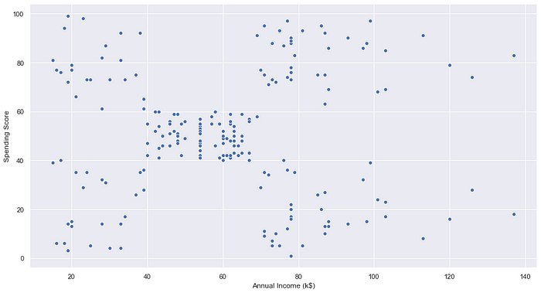

#Find the K value using the Elbow method
wcss=[]
for i in range(1,11):
kmeans = KMeans(n_clusters=i, init='k-means++', random_state=2)
kmeans.fit(X)
wcss.append(kmeans.inertia_)
plt.figure(figsize=(15,8))
plt.plot(range(1,11), wcss)
plt.title('The Elbow Point Graph')
plt.xlabel('Number of Clusters (K)')
plt.ylabel('wcss')
plt.show()

#WCSS doesn’t reduce much after k=5. So, we can choose 5 as the perfect K value or Clusters.

#Training the K-means algorithm on the training dataset
kmeans = KMeans(n_clusters=5, init='k-means++', random_state=0)
Y = kmeans.fit_predict(X)

#Centroid points
kmeans.cluster_centers_

array([[88.2 , 17.11428571],
[55.2962963 , 49.51851852],
[86.53846154, 82.12820513],
[25.72727273, 79.36363636],
[26.30434783, 20.91304348]])
#Visualize the clusters formed
plt.figure(figsize=(15,8))
plt.scatter(X[Y==0,0], X[Y==0,1], s=50, c='red', label='Cluster 1')
plt.scatter(X[Y==1,0], X[Y==1,1], s=50, c='pink', label='Cluster 2')
plt.scatter(X[Y==2,0], X[Y==2,1], s=50, c='yellow', label='Cluster 3')
plt.scatter(X[Y==3,0], X[Y==3,1], s=50, c='green', label='Cluster 4')
plt.scatter(X[Y==4,0], X[Y==4,1], s=50, c='orange', label='Cluster 5')
plt.scatter(kmeans.cluster_centers_[:,0], kmeans.cluster_centers_[:,1], s=200, c='black', label='Centroids')
plt.title('Customer Groups')
plt.xlabel('Annual Income')
plt.ylabel('Spending Score')
plt.show()
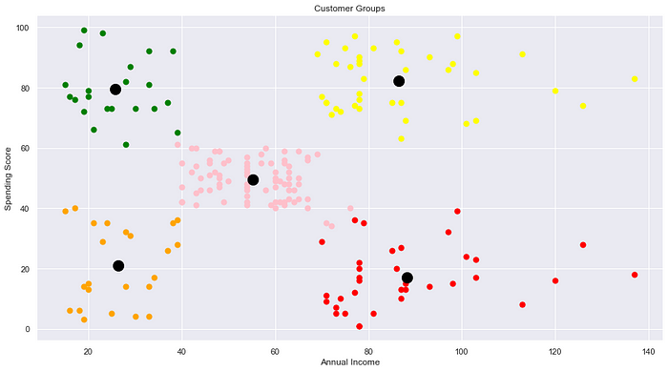

Conclusion:
In this blog, we discussed one of the most famous clustering algorithms: K-Means. We can clearly see the five clusters formed. The black dots represent the centroid for each cluster.

WEEK-10:
10) Performance analysis of Classification Algorithms on a specific dataset (Mini
Project)

💳💲 Loan Prediction with Various ML Models 💵

Table of Contents
1. Introduction
2. Importing Libraries
3. Reading Data Set
4. Data Exploration
5. Data Preprocessing
6. Models
7. Model Comparison

1. Introduction


Data Set Problems
👉 The company seeks to automate (in real time) the loan qualifying procedure based on information given by customers while filling out an online application form. It is expected that the development of ML models that can help the company predict loan approval in accelerating decision-making process for determining whether an applicant is eligible for a loan or not.

Objectives of Project
👉 This project aims to:
- Analyze customer data provided in data set (EDA)
- Build various ML models that can predict loan approval
‍💻 The machine learning models used in this project are:
- Logistic Regression
- K-Nearest Neighbour (KNN)
- Support Vector Machine (SVM)
- Naive Bayes
- Decision Tree
- Random Forest
- Gradient Boost

Data Set Description
👉There are 13 variables in this data set:
- 8 categorical variables,
- 4 continuous variables, and
- 1 variable to accommodate the loan ID.

👉The following is the structure of the data set.

Variable Name | Description | Sample Data
Loan_ID | Loan reference number  (unique ID) | LP001002; LP001003; ...
Gender | Applicant gender  (Male or Female) | Male; Female
Married | Applicant marital status  (Married or not married) | Married; Not Married
Dependents | Number of family members | 0; 1; 2; 3+
Education | Applicant education/qualification  (graduate or not graduate) | Graduate; Under Graduate
Self_Employed | Applicant employment status  (yes for self-employed, no for employed/others) | Yes; No
ApplicantIncome | Applicant's monthly salary/income | 5849; 4583; ...
CoapplicantIncome | Additional applicant's monthly salary/income | 1508; 2358; ...
LoanAmount | Loan amount | 128; 66; ...
Loan_Amount_Term | The loan's repayment period (in days) | 360; 120; ...
Credit_History | Records of previous credit history  (0: bad credit history, 1: good credit history) | 0; 1
Property_Area | The location of property  (Rural/Semiurban/Urban) | Rural; Semiurban; Urban
Loan_Status | Status of loan  (Y: accepted, N: not accepted) | Y; N

2. Importing Libraries
👉Importing libraries that will be used in this notebook.
In [1]:
Import numpyasnp
Import pandasaspd
Import matplotlib.pyplotasplt
Import missingnoasmso
Import seabornassns
Import warnings
Import os
Import scipy

From scipy import stats
From scipy.stats import pearsonr
From scipy.stats importttest_ind
From sklearn.metrics import classification_report
from sklearn.metrics import confusion_matrix
from sklearn.preprocessing import MinMaxScaler
from sklearn.model_selection import train_test_split
from imblearn.over_sampling import SMOTE

from sklearn.linear_model import LogisticRegression
from sklearn.neighbors import KNeighborsClassifier
from sklearn.svm import SVC
from sklearn.naive_bayes import CategoricalNB
from sklearn.naive_bayes import GaussianNB
from sklearn.tree import DecisionTreeClassifier
from sklearn.ensemble import RandomForestClassifier
from sklearn.ensemble import GradientBoostingClassifier
from xgboost import XGBClassifier
from sklearn.model_selection import GridSearchCV,RandomizedSearchCV

3. Reading Data Set
👉After importing libraries, we will also import the dataset that will be used.
In [2]:
df=pd.read_csv("../input/loan-predication.csv")
df.head()

df.shape

(614, 13)

As can be seen, the 13 columns are readable. It also can be seen that there are 614 observations in the data set.

4. Data Exploration
👉This section will perform data exploration of "raw" data set that has been imported.

4.1 Categorical Variable
👉The first type of variable that I will explore is categorical variable.

4.1.1 Loan ID
In [4]:
df.Loan_ID.value_counts(dropna=False)
Out[4]:
LP001002 1
LP002328 1
LP002305 1
LP002308 1
LP002314 1
..
LP001692 1
LP001693 1
LP001698 1
LP001699 1
LP002990 1
Name: Loan_ID, Length: 614, dtype: int64
👉 It can be seen that there are 614 unique ID in the dataset.

4.1.2 Gender
In [5]:
df.Gender.value_counts(dropna=False)
Out[5]:
Male 489
Female 112
NaN 13
Name: Gender, dtype: int64
In [6]:
sns.countplot(x="Gender",data=df,palette="hls")
plt.show()

In [7]:
countMale=len(df[df.Gender=='Male'])
countFemale=len(df[df.Gender=='Female'])
countNull=len(df[df.Gender.isnull()])

print("Percentage of Male applicant: {:.2f}%".format((countMale/(len(df.Gender))*100)))
print("Percentage of Female applicant: {:.2f}%".format((countFemale/(len(df.Gender))*100)))
print("Missing values percentage: {:.2f}%".format((countNull/(len(df.Gender))*100)))
Percentage of Male applicant: 79.64%
Percentage of Female applicant: 18.24%
Missing values percentage: 2.12%
👉From the results above, the number of male applicants is higher compared to female applicants. It also can be seen there are missing values in this column.

4.1.3 Married
In [8]:
df.Married.value_counts(dropna=False)
Out[8]:
Yes 398
No 213
NaN 3
Name: Married, dtype: int64
In [9]:
sns.countplot(x="Married",data=df,palette="Paired")
plt.show()

👉The number of applicants that has been married is higher compared to applicants that hasn't married. It also can be seen there are small number of missing values in this column.
In [10]:
countMarried=len(df[df.Married=='Yes'])
countNotMarried=len(df[df.Married=='No'])
countNull=len(df[df.Married.isnull()])

print("Percentage of married: {:.2f}%".format((countMarried/(len(df.Married))*100)))
print("Percentage of Not married applicant: {:.2f}%".format((countNotMarried/(len(df.Married))*100)))
print("Missing values percentage: {:.2f}%".format((countNull/(len(df.Married))*100)))
Percentage of married: 64.82%
Percentage of Not married applicant: 34.69%
Missing values percentage: 0.49%

4.1.4 Education
In [11]:
df.Education.value_counts(dropna=False)
Out[11]:
Graduate 480
Not Graduate 134
Name: Education, dtype: int64
In [12]:
sns.countplot(x="Education",data=df,palette="rocket")
plt.show()

In [13]:
countGraduate=len(df[df.Education=='Graduate'])
countNotGraduate=len(df[df.Education=='Not Graduate'])
countNull=len(df[df.Education.isnull()])

print("Percentage of graduate applicant: {:.2f}%".format((countGraduate/(len(df.Education))*100)))
print("Percentage of Not graduate applicant: {:.2f}%".format((countNotGraduate/(len(df.Education))*100)))
print("Missing values percentage: {:.2f}%".format((countNull/(len(df.Education))*100)))
Percentage of graduate applicant: 78.18%
Percentage of Not graduate applicant: 21.82%
Missing values percentage: 0.00%
👉The number of applicants that has been graduated is higher compared to applicants that hasn't graduated.

4.1.5 Self Employed
In [14]:
df.Self_Employed.value_counts(dropna=False)
Out[14]:
No 500
Yes 82
NaN 32
Name: Self_Employed, dtype: int64
In [15]:
sns.countplot(x="Self_Employed",data=df,palette="crest")
plt.show()

In [16]:
countNo=len(df[df.Self_Employed=='No'])
countYes=len(df[df.Self_Employed=='Yes'])
countNull=len(df[df.Self_Employed.isnull()])

print("Percentage of Not self employed: {:.2f}%".format((countNo/(len(df.Self_Employed))*100)))
print("Percentage of self employed: {:.2f}%".format((countYes/(len(df.Self_Employed))*100)))
print("Missing values percentage: {:.2f}%".format((countNull/(len(df.Self_Employed))*100)))
Percentage of Not self employed: 81.43%
Percentage of self employed: 13.36%
Missing values percentage: 5.21%
👉The number of applicants that are not self employed is higher compared to applicants that are self employed. It also can be seen, there are missing values in this column.

4.1.6 Credit History
In [17]:
df.Credit_History.value_counts(dropna=False)

Out[17]:
1.0 475
0.0 89
NaN 50
Name: Credit_History, dtype: int64
In [18]:
sns.countplot(x="Credit_History",data=df,palette="viridis")
plt.show()

In [19]:
count1=len(df[df.Credit_History==1])
count0=len(df[df.Credit_History==0])
countNull=len(df[df.Credit_History.isnull()])

print("Percentage of Good credit history: {:.2f}%".format((count1/(len(df.Credit_History))*100)))
print("Percentage of Bad credit history: {:.2f}%".format((count0/(len(df.Credit_History))*100)))
print("Missing values percentage: {:.2f}%".format((countNull/(len(df.Credit_History))*100)))
Percentage of Good credit history: 77.36%
Percentage of Bad credit history: 14.50%
Missing values percentage: 8.14%
👉The number of applicants that have good credit history is higher compared to applicants that have bad credit history. It also can be seen, there are missing values in this column.

4.1.7 Property Area
In [20]:
df.Property_Area.value_counts(dropna=False)
Out[20]:
Semiurban 233
Urban 202
Rural 179
Name: Property_Area, dtype: int64
In [21]:
sns.countplot(x="Property_Area",data=df,palette="cubehelix")
plt.show()
In [22]:
countUrban=len(df[df.Property_Area=='Urban'])
countRural=len(df[df.Property_Area=='Rural'])
countSemiurban=len(df[df.Property_Area=='Semiurban'])
countNull=len(df[df.Property_Area.isnull()])

print("Percentage of Urban: {:.2f}%".format((countUrban/(len(df.Property_Area))*100)))
print("Percentage of Rural: {:.2f}%".format((countRural/(len(df.Property_Area))*100)))
print("Percentage of Semiurban: {:.2f}%".format((countSemiurban/(len(df.Property_Area))*100)))
print("Missing values percentage: {:.2f}%".format((countNull/(len(df.Property_Area))*100)))
Percentage of Urban: 32.90%
Percentage of Rural: 29.15%
Percentage of Semiurban: 37.95%
Missing values percentage: 0.00%
👉This column has a balanced distribution between Urban, Rural, and Semiurban property area. It also can be seen there is no missing value.

4.1.8 Loan Status
In [23]:
df.Loan_Status.value_counts(dropna=False)
Out[23]:
Y 422
N 192
Name: Loan_Status, dtype: int64
In [24]:
sns.countplot(x="Loan_Status",data=df,palette="YlOrBr")
plt.show()

In [25]:
countY=len(df[df.Loan_Status=='Y'])
countN=len(df[df.Loan_Status=='N'])
countNull=len(df[df.Loan_Status.isnull()])

print("Percentage of Approved: {:.2f}%".format((countY/(len(df.Loan_Status))*100)))
print("Percentage of Rejected: {:.2f}%".format((countN/(len(df.Loan_Status))*100)))
print("Missing values percentage: {:.2f}%".format((countNull/(len(df.Loan_Status))*100)))
Percentage of Approved: 68.73%
Percentage of Rejected: 31.27%
Missing values percentage: 0.00%
👉 The number of approved loans is higher compared to rejected loans . It also can be seen, there is no missing values in this column.

4.1.9 Loan Amount Term
In [26]:
df.Loan_Amount_Term.value_counts(dropna=False)
Out[26]:
360.0 512
180.0 44
480.0 15
NaN 14
300.0 13
240.0 4
84.0 4
120.0 3
60.0 2
36.0 2
12.0 1
Name: Loan_Amount_Term, dtype: int64
In [27]:
sns.countplot(x="Loan_Amount_Term",data=df,palette="rocket")
plt.show()

In [28]:
count12=len(df[df.Loan_Amount_Term==12.0])
count36=len(df[df.Loan_Amount_Term==36.0])
count60=len(df[df.Loan_Amount_Term==60.0])
count84=len(df[df.Loan_Amount_Term==84.0])
count120=len(df[df.Loan_Amount_Term==120.0])
count180=len(df[df.Loan_Amount_Term==180.0])
count240=len(df[df.Loan_Amount_Term==240.0])
count300=len(df[df.Loan_Amount_Term==300.0])
count360=len(df[df.Loan_Amount_Term==360.0])
count480=len(df[df.Loan_Amount_Term==480.0])
countNull=len(df[df.Loan_Amount_Term.isnull()])

print("Percentage of 12: {:.2f}%".format((count12/(len(df.Loan_Amount_Term))*100)))
print("Percentage of 36: {:.2f}%".format((count36/(len(df.Loan_Amount_Term))*100)))
print("Percentage of 60: {:.2f}%".format((count60/(len(df.Loan_Amount_Term))*100)))
print("Percentage of 84: {:.2f}%".format((count84/(len(df.Loan_Amount_Term))*100)))
print("Percentage of 120: {:.2f}%".format((count120/(len(df.Loan_Amount_Term))*100)))
print("Percentage of 180: {:.2f}%".format((count180/(len(df.Loan_Amount_Term))*100)))
print("Percentage of 240: {:.2f}%".format((count240/(len(df.Loan_Amount_Term))*100)))
print("Percentage of 300: {:.2f}%".format((count300/(len(df.Loan_Amount_Term))*100)))
print("Percentage of 360: {:.2f}%".format((count360/(len(df.Loan_Amount_Term))*100)))
print("Percentage of 480: {:.2f}%".format((count480/(len(df.Loan_Amount_Term))*100)))
print("Missing values percentage: {:.2f}%".format((countNull/(len(df.Loan_Amount_Term))*100)))
Percentage of 12: 0.16%
Percentage of 36: 0.33%
Percentage of 60: 0.33%
Percentage of 84: 0.65%
Percentage of 120: 0.49%
Percentage of 180: 7.17%
Percentage of 240: 0.65%
Percentage of 300: 2.12%
Percentage of 360: 83.39%
Percentage of 480: 2.44%
Missing values percentage: 2.28%
👉As can be seen from the results, the 360 days loan duration is the most popular compared to others.

4.2 Numerical Variable
👉The second variable that I will explore is categorical variable.

4.2.1 Describe Numerical Variable
👉This section will show mean, count, std, min, max and others using describe function.
In [29]:
df[['ApplicantIncome','CoapplicantIncome','LoanAmount']].describe()
Out[29]:
 | ApplicantIncome | CoapplicantIncome | LoanAmount
count | 614.000000 | 614.000000 | 592.000000
mean | 5403.459283 | 1621.245798 | 146.412162
std | 6109.041673 | 2926.248369 | 85.587325
min | 150.000000 | 0.000000 | 9.000000
25% | 2877.500000 | 0.000000 | 100.000000
50% | 3812.500000 | 1188.500000 | 128.000000
75% | 5795.000000 | 2297.250000 | 168.000000
max | 81000.000000 | 41667.000000 | 700.000000

4.2.2 Distribution of Numerical Variable 📈
👉In this section, I will show the distribution of numerical variable using histogram and violin plot.

4.2.2.1 Histogram Distribution 📉
In [30]:
sns.set(style="darkgrid")
fig,axs=plt.subplots(2,2,figsize=(10,8))

sns.histplot(data=df,x="ApplicantIncome",kde=True,ax=axs[0,0],color='green')
sns.histplot(data=df,x="CoapplicantIncome",kde=True,ax=axs[0,1],color='skyblue')
sns.histplot(data=df,x="LoanAmount",kde=True,ax=axs[1,0],color='orange');

4.2.2.2 Violin Plot 🎻
In [31]:
sns.set(style="darkgrid")
fig,axs1=plt.subplots(2,2,figsize=(10,10))

sns.violinplot(data=df,y="ApplicantIncome",ax=axs1[0,0],color='green')
sns.violinplot(data=df,y="CoapplicantIncome",ax=axs1[0,1],color='skyblue')
sns.violinplot(data=df,y="LoanAmount",ax=axs1[1,0],color='orange');

- The distribution of Applicant income, Co Applicant Income, and Loan Amount are positively skewed and it has outliers (can be seen from both histogram and violin plot).
- The distribution of Loan Amount Term is negativly skewed and it has outliers.

4.3 Other Exploration
👉This section will show additional exploration from each variables. The additional exploration are:
- Bivariate analysis (categorical w/ categorical, categroical w/ numerical, and numerical w/ numerical)
- Heatmap

4.3.1 Heatmap 🔥
In [32]:
plt.figure(figsize=(10,7))
sns.heatmap(df.corr(),annot=True,cmap='inferno');

👉There is positive correlation between Loan Amount and Applicant Income

4.3.2 Categorical - Categorical
In [33]:
pd.crosstab(df.Gender,df.Married).plot(kind="bar",stacked=True,figsize=(5,5),color=['#f64f59','#12c2e9'])
plt.title('Gender vs Married')
plt.xlabel('Gender')
plt.ylabel('Frequency')
plt.xticks(rotation=0)
plt.show()

👉Most male applicants are already married compared to female applicants. Also, the number of not married male applicants are higher compare to female applicants that had not married.
In [34]:
pd.crosstab(df.Self_Employed,df.Credit_History).plot(kind="bar",stacked=True,figsize=(5,5),color=['#544a7d','#ffd452'])
plt.title('Self Employed vs Credit History')
plt.xlabel('Self Employed')
plt.ylabel('Frequency')
plt.legend(["Bad Credit","Good Credit"])
plt.xticks(rotation=0)
plt.show()

👉Most not self employed applicants have good credit compared to self employed applicants.
In [35]:
pd.crosstab(df.Property_Area,df.Loan_Status).plot(kind="bar",stacked=True,figsize=(5,5),color=['#333333','#dd1818'])
plt.title('Property Area vs Loan Status')
plt.xlabel('Property Area')
plt.ylabel('Frequency')
plt.xticks(rotation=0)
plt.show()

👉 Most of loan that got accepted has property in Semiurban compared to Urban and Rural.

4.3.3 Categorical 📊- Numerical 📈
In [36]:
sns.boxplot(x="Loan_Status",y="ApplicantIncome",data=df,palette="mako");

👉It can be seen that there are lots of outliers in Applicant Income, and the distribution also positively skewed
In [37]:
sns.boxplot(x="CoapplicantIncome",y="Loan_Status",data=df,palette="rocket");

👉It's clear that Co Applicant Income has a number of outliers, and the distribution is also positively skewed.
In [38]:
sns.boxplot(x="Loan_Status",y="LoanAmount",data=df,palette="YlOrBr");

👉As can be seen, Co Applicant Income has a high number of outliers, and the distribution is also positively skewed.

4.3.4 Numerical 📈 - Numerical 📈
In [39]:
df.plot(x='ApplicantIncome',y='CoapplicantIncome',style='o')
plt.title('Applicant Income - Co Applicant Income')
plt.xlabel('ApplicantIncome')
plt.ylabel('CoapplicantIncome')
plt.show()
print('Pearson correlation:',df['ApplicantIncome'].corr(df['CoapplicantIncome']))
print('T Test and P value: \n',stats.ttest_ind(df['ApplicantIncome'],df['CoapplicantIncome']))

Pearson correlation: -0.11660458122889966
T Test and P value:
Ttest_indResult(statistic=13.835753259915661, pvalue=1.4609839484240346e-40)
- There is negative correlation between Applicant income and Co Applicant Income.
- The correlation coefficient is significant at the 95 per cent confidence interval, as it has a p-value of 1.46

4.4 Null Values 🚫
In [40]:
df.isnull().sum()
Out[40]:
Loan_ID 0
Gender 13
Married 3
Dependents 15
Education 0
Self_Employed 32
ApplicantIncome 0
CoapplicantIncome 0
LoanAmount 22
Loan_Amount_Term 14
Credit_History 50
Property_Area 0
Loan_Status 0
dtype: int64
In [41]:
plt.figure(figsize=(24,5))
axz=plt.subplot(1,2,2)
mso.bar(df,ax=axz,fontsize=12);

👉Previously, the null values has been explored for Categorical Variables. In this section, the null values has been explored for all variables in the dataset.

5. Data Preprocessing

5.1 Drop Unecessary Variables
👉 Unecessary variables will be dropped in this section.
In [42]:
df=df.drop(['Loan_ID'],axis=1)

5.2 Data Imputation
👉 Imputation is a technique for substituting an estimated value for missing values in a dataset. In this section, the imputation will be performed for variables that have missing values.

5.2.1 Categorical Variables
👉In this section, the imputation for categorical variables will be performed using mode.
In [43]:
df['Gender'].fillna(df['Gender'].mode()[0],inplace=True)
df['Married'].fillna(df['Married'].mode()[0],inplace=True)
df['Dependents'].fillna(df['Dependents'].mode()[0],inplace=True)
df['Self_Employed'].fillna(df['Self_Employed'].mode()[0],inplace=True)
df['Credit_History'].fillna(df['Credit_History'].mode()[0],inplace=True)
df['Loan_Amount_Term'].fillna(df['Loan_Amount_Term'].mode()[0],inplace=True)

5.2.2 Numerical Variables
👉The next section is imputation for numerical variables using mean.
In [44]:
df['LoanAmount'].fillna(df['LoanAmount'].mean(),inplace=True)

5.3 One-hot Encoding
👉In this section, I will transform categorical variables into a form that could be provided by ML algorithms to do a better prediction.
In [45]:
df=pd.get_dummies(df)

# Drop columns
df=df.drop(['Gender_Female','Married_No','Education_Not Graduate',
'Self_Employed_No','Loan_Status_N'],axis=1)

# Rename columns name
new={'Gender_Male':'Gender','Married_Yes':'Married',
'Education_Graduate':'Education','Self_Employed_Yes':'Self_Employed',
'Loan_Status_Y':'Loan_Status'}

df.rename(columns=new,inplace=True)

5.3 Remove Outliers & Infinite values
👉Since there are outliers, the outliers will be removed.
In [46]:
Q1=df.quantile(0.25)
Q3=df.quantile(0.75)
IQR=Q3-Q1

df=df[~((df<(Q1-1.5*IQR))|(df>(Q3+1.5*IQR))).any(axis=1)]

5.4 Skewed Distribution Treatment
👉In previous section, it already shown that distribution for ApplicantIncome, CoapplicantIncome, and LoanAmount is positively skewed.
👉 I will use square root transformation to normalized the distribution.
In [47]:
# Square Root Transformation

df.ApplicantIncome=np.sqrt(df.ApplicantIncome)
df.CoapplicantIncome=np.sqrt(df.CoapplicantIncome)
df.LoanAmount=np.sqrt(df.LoanAmount)
In [48]:
sns.set(style="darkgrid")
fig,axs=plt.subplots(2,2,figsize=(10,8))

sns.histplot(data=df,x="ApplicantIncome",kde=True,ax=axs[0,0],color='green')
sns.histplot(data=df,x="CoapplicantIncome",kde=True,ax=axs[0,1],color='skyblue')
sns.histplot(data=df,x="LoanAmount",kde=True,ax=axs[1,0],color='orange');

👉As can be seen, the distribution after using log transformation are much better compared to original distribution.

5.5 Features Separating
👉 Dependent features (Loan_Status) will be seperated from independent features.
In [49]:
X=df.drop(["Loan_Status"],axis=1)
y=df["Loan_Status"]

5.6 SMOTE Technique
👉In previous exploration, it can be seen that the number between approved and rejected loan is imbalanced. In this section, oversampling technique will be used to avoid overfitting,
In [50]:
X,y=SMOTE().fit_resample(X,y)
In [51]:
sns.set_theme(style="darkgrid")
sns.countplot(y=y,data=df,palette="coolwarm")
plt.ylabel('Loan Status')
plt.xlabel('Total')
plt.show()

👉As can be seen, the distrubtion of Loan status are now balanced.

5.7 Data Normalization
👉In this section, data normalization will be performed to normalize the range of independent variables or features of data.
In [52]:
X=MinMaxScaler().fit_transform(X)

5.8 Splitting Data Set
👉The data set will be split into 80% train and 20% test.
In [53]:
X_train,X_test,y_train,y_test=train_test_split(X,y,test_size=0.2,random_state=0)

6. Models

6.1 Logistic Regression
In [54]:
LRclassifier=LogisticRegression(solver='saga',max_iter=500,random_state=1)
LRclassifier.fit(X_train,y_train)

y_pred=LRclassifier.predict(X_test)

print(classification_report(y_test,y_pred))
print(confusion_matrix(y_test,y_pred))

from sklearn.metrics import accuracy_score
LRAcc=accuracy_score(y_pred,y_test)
print('LR accuracy: {:.2f}%'.format(LRAcc*100))
precision recall f1-score support

0 0.83 0.87 0.85 23
1 0.86 0.82 0.84 22

accuracy 0.84 45
macro avg 0.85 0.84 0.84 45
weighted avg 0.84 0.84 0.84 45

[[20 3]
[ 4 18]]
LR accuracy: 84.44%

6.2 K-Nearest Neighbour (KNN)
In [55]:
scoreListknn=[]
for i in range(1,21):
KNclassifier=KNeighborsClassifier(n_neighbors=i)
KNclassifier.fit(X_train,y_train)
scoreListknn.append(KNclassifier.score(X_test,y_test))

plt.plot(range(1,21),scoreListknn)
plt.xticks(np.arange(1,21,1))
plt.xlabel("K value")
plt.ylabel("Score")
plt.show()
KNAcc=max(scoreListknn)
print("KNN best accuracy: {:.2f}%".format(KNAcc*100))

KNN best accuracy: 91.11%

6.3 Support Vector Machine (SVM)
In [56]:
SVCclassifier=SVC(kernel='rbf',max_iter=500)
SVCclassifier.fit(X_train,y_train)

y_pred=SVCclassifier.predict(X_test)

print(classification_report(y_test,y_pred))
print(confusion_matrix(y_test,y_pred))

fromsklearn.metricsimportaccuracy_score
SVCAcc=accuracy_score(y_pred,y_test)
print('SVC accuracy: {:.2f}%'.format(SVCAcc*100))
precision recall f1-score support

0 0.87 0.87 0.87 23
1 0.86 0.86 0.86 22

accuracy 0.87 45
macro avg 0.87 0.87 0.87 45
weighted avg 0.87 0.87 0.87 45

[[20 3]
[ 3 19]]
SVC accuracy: 86.67%

6.4 Naive Bayes

6.4.1 Categorical NB
In [57]:
NBclassifier1=CategoricalNB()
NBclassifier1.fit(X_train,y_train)

y_pred=NBclassifier1.predict(X_test)

print(classification_report(y_test,y_pred))
print(confusion_matrix(y_test,y_pred))

fromsklearn.metricsimportaccuracy_score
NBAcc1=accuracy_score(y_pred,y_test)
print('Categorical Naive Bayes accuracy: {:.2f}%'.format(NBAcc1*100))
precision recall f1-score support

0 0.81 0.74 0.77 23
1 0.75 0.82 0.78 22

accuracy 0.78 45
macro avg 0.78 0.78 0.78 45
weighted avg 0.78 0.78 0.78 45

[[17 6]
[ 4 18]]

Categorical Naive Bayes accuracy: 77.78%

6.4.2 Gaussian NB
In [58]:
NBclassifier2=GaussianNB()
NBclassifier2.fit(X_train,y_train)

y_pred=NBclassifier2.predict(X_test)

print(classification_report(y_test,y_pred))
print(confusion_matrix(y_test,y_pred))

fromsklearn.metricsimportaccuracy_score
NBAcc2=accuracy_score(y_pred,y_test)
print('Gaussian Naive Bayes accuracy: {:.2f}%'.format(NBAcc2*100))
precision recall f1-score support

0 0.77 0.87 0.82 23
1 0.84 0.73 0.78 22

accuracy 0.80 45
macro avg 0.81 0.80 0.80 45
weighted avg 0.80 0.80 0.80 45

[[20 3]
[ 6 16]]

Gaussian Naive Bayes accuracy: 80.00%

6.5 Decision Tree
In [59]:
scoreListDT=[]
foriinrange(2,21):
DTclassifier=DecisionTreeClassifier(max_leaf_nodes=i)
DTclassifier.fit(X_train,y_train)
scoreListDT.append(DTclassifier.score(X_test,y_test))

plt.plot(range(2,21),scoreListDT)
plt.xticks(np.arange(2,21,1))
plt.xlabel("Leaf")
plt.ylabel("Score")
plt.show()
DTAcc=max(scoreListDT)
print("Decision Tree Accuracy: {:.2f}%".format(DTAcc*100))

Decision Tree Accuracy: 86.67%

6.6 Random Forest
In [60]:
scoreListRF=[]
foriinrange(2,25):
RFclassifier=RandomForestClassifier(n_estimators=1000,random_state=1,max_leaf_nodes=i)
RFclassifier.fit(X_train,y_train)
scoreListRF.append(RFclassifier.score(X_test,y_test))

plt.plot(range(2,25),scoreListRF)
plt.xticks(np.arange(2,25,1))
plt.xlabel("RF Value")
plt.ylabel("Score")
plt.show()
RFAcc=max(scoreListRF)
print("Random Forest Accuracy: {:.2f}%".format(RFAcc*100))

Random Forest Accuracy: 93.33%

6.7 Gradient Boosting
In [61]:
paramsGB={'n_estimators':[100,200,300,400,500],
'max_depth':[1,2,3,4,5],
'subsample':[0.5,1],
'max_leaf_nodes':[2,5,10,20,30,40,50]}
In [62]:
GB=RandomizedSearchCV(GradientBoostingClassifier(),paramsGB,cv=20)
GB.fit(X_train,y_train)
Out[62]:
RandomizedSearchCV(cv=20, estimator=GradientBoostingClassifier(),
param_distributions={'max_depth': [1, 2, 3, 4, 5],
'max_leaf_nodes': [2, 5, 10, 20, 30, 40
50],
'n_estimators': [100, 200, 300, 400,
500],
'subsample': [0.5, 1]})
In [63]:
print(GB.best_estimator_)
print(GB.best_score_)
print(GB.best_params_)
print(GB.best_index_)
GradientBoostingClassifier(max_depth=4, max_leaf_nodes=50, n_estimators=400,
subsample=1)
0.8270833333333332
{'subsample': 1, 'n_estimators': 400, 'max_leaf_nodes': 50, 'max_depth': 4}
9
In [64]:
GBclassifier=GradientBoostingClassifier(subsample=0.5,n_estimators=400,max_depth=4,max_leaf_nodes=10)
GBclassifier.fit(X_train,y_train)

y_pred=GBclassifier.predict(X_test)

print(classification_report(y_test,y_pred))
print(confusion_matrix(y_test,y_pred))

fromsklearn.metricsimportaccuracy_score
GBAcc=accuracy_score(y_pred,y_test)
print('Gradient Boosting accuracy: {:.2f}%'.format(GBAcc*100))
precision recall f1-score support

0 0.77 0.87 0.82 23
1 0.84 0.73 0.78 22

accuracy 0.80 45
macro avg 0.81 0.80 0.80 45
weighted avg 0.80 0.80 0.80 45

[[20 3]
[ 6 16]]

Gradient Boosting accuracy: 80.00%

7. Model Comparison
In [65]:
compare=pd.DataFrame({'Model':['Logistic Regression','K Neighbors',
'SVM','Categorical NB',
'Gaussian NB','Decision Tree',
'Random Forest','Gradient Boost'],
'Accuracy':[LRAcc*100,KNAcc*100,SVCAcc*100,
NBAcc1*100,NBAcc2*100,DTAcc*100,
RFAcc*100,GBAcc*100]})
compare.sort_values(by='Accuracy',ascending=False)

OUTPUT:

 | Model | Accuracy
6 | Random Forest | 93.333333
1 | K Neighbors | 91.111111
2 | SVM | 86.666667
5 | Decision Tree | 86.666667
0 | Logistic Regression | 84.444444
4 | Gaussian NB | 80.000000
7 | Gradient Boost | 80.000000
3 | Categorical NB | 77.777778
- In general, it can be seen that all models can achieve up to 70% accuracy.
The highest accuracy is 93%%.

